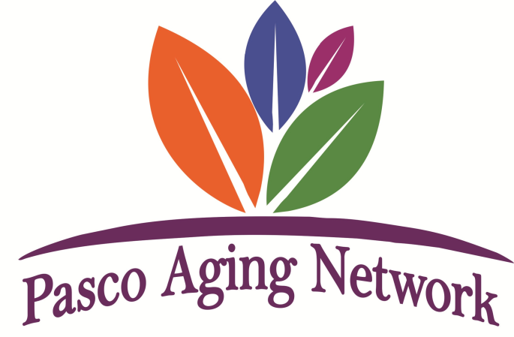
January 11, 2023
“The mission of PAN is to promote continuing service excellence to seniors through proactive, visionary and ethical leadership in networking, education and collaboration.”
AGENDA
8:00 – 8:15 Sign-in and Networking
8:15 – Welcome & Pledge- Marianne Brawer, President -President’s report silence cell phones
*All encouraged to bring brochures, flyers and cards for front sign in tables. Main tables host and speaker info only.
*Intro of 2023 Board- Vice President – Ryan Abremski, Treasurer – Adam Shoemaker, Secretary – Marina McLoone
Immediate Past President – Katie Levinson and Marianne Brawer, President 2023

8:25 Introduction of our Mtg. Hosts – Vice President Ryan Abremski
-Michels & Lundquist *Patricia thanked Jimmy Altmyer, Jim, Sarah, Lou
-Pass the Basket for Host’s Charity of Choice *$137 collected for Gulfside Hospice/Carla Armstrong

8:35 – 8:45 Education – Intro speaker – Marianne, Ryan and Lori Felber
-Honor Flight *Mark Welsh 727498-6079 www.honorflightwct.org Next flight 4/25/23 StPete/Clwtr airport
Information being emailed to PAN 1/12/23 by Marianne. Encouraged to participate in Mail Call , notes to vets,
Participation applications shared-past PAN Grants paid $500/guardian members
ie: a few previous grant recipients for PAN guardians were Marianne, Lori, Adam. Inquire if interested.

8:45 – 9:00 PAN Committee Reports:
Publicity, Website Support - Christine Plescher-*Email brochures, flyers to be shared-see below
Membership - Janeen Salzgeber-* 57members, 6guests 2 visits encouraged and $50 join suggested
Boots & Bling – Mary Sommise & Marianne Brawer-
*Marianne announced date: Saturday May 13, 2023-SSGCC, Current Sponsors and collection of lotto tickets for
fundraising tree each meeting encouraged ($10 in tickets collected)
Special Projects: Senior Resource Grants – Marianne, Paul Lallanilla, Katie Levinson
*Marianne announced $22,000 given to 18 agencies in 2022
Resources & Referrals – Jillian Rose AAAPP-*announced Impact reports due-email sent.
*Website to be updated- 2023 Grant Program Applications-not yet available (Funds for Grants raised by 1 Fundraiser)
* AAAPP Annual Luncheon 5/16/23-flyers distributed- 1/11 in FL audited by Elder Affairs 2022-No findings

9:00 - Introduction of PAN Members, 30 seconds – members only
9:20 – Announcements if time allows – if not send flyers to Christine as jpeg or png
* agapeseniorsolutions@gmail.com or call 727-742-8232 Again, these can be placed on front tables near sign in
9:30 – Adjournment
Next meeting: Feb. 8, host HPH Hospice being held CARES Hudson RSVP to www.pascoagingnetwork.org

** Pasco Aging Network does not promote or vouch for the services provided by any of its members. Members wishing to do business with one another are strongly encouraged to do their own public records searches and background screenings before entering into any business relationship. PAN accepts no liability for any information identified from those searches/screenings or any claims arising from any verbal or written agreements members may engage with one another.

